Linear Systems & Augmented Matrices

Geometrical Representation of Solutions of Linear Equations
Given an equation, we can represent its solutions geometrically.
For example, given the formula, we can represent all the solutions as a line.

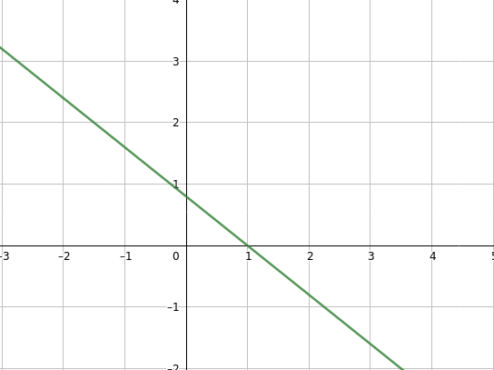
Similarly, for the general equation, we can represent it’s solutions as a plane.

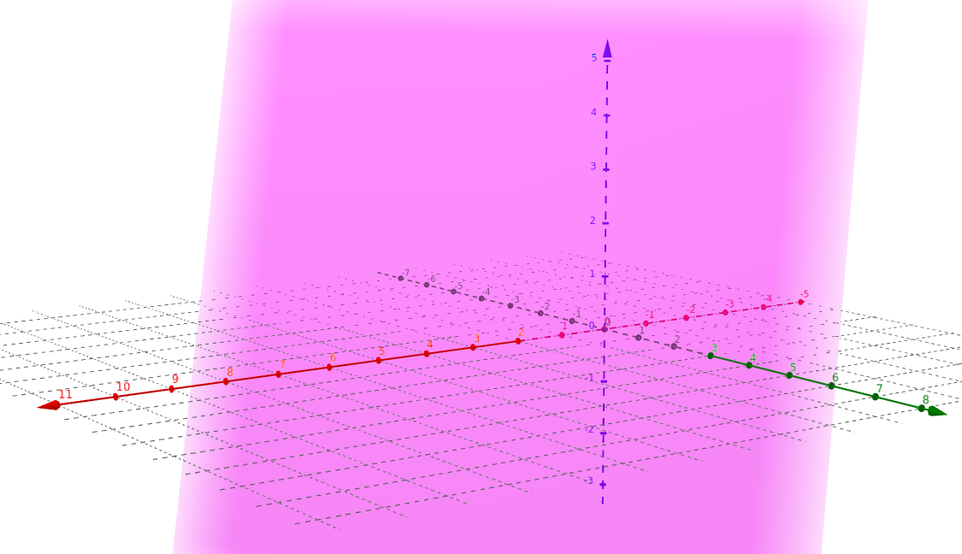
Givenreal numbers, we say thatis a solution to a linear equationif the equation is satisfied when we substitute the values into the equation accordingly.

Example:

General Solutions of Linear Equations
Consider the linear equationwhich has infinitely many solutions.

The general solution is

whereis an arbitrary parameter.

We can also write the general solution as

whereis an arbitrary parameter.

Augmented Matrices
A system of linear equations can be represented by an augmented matrix.

can be represented as.

Homogeneous Linear Systems
A system of linear equations is homogeneous if all the constant terms are zero.

or

A homogeneous linear system always has the origin as the solution. The origin is called the trivial solution. Any other solution is called a non-trivial solution. Since any linear system may only have 0, 1 or inifinte number of solutions, and a homogenous linear system always has the origin as its solution, we can deduce that a homogenous linear
system will either have 1 or inifinite number of solutions.

